Queensland Ballet presents
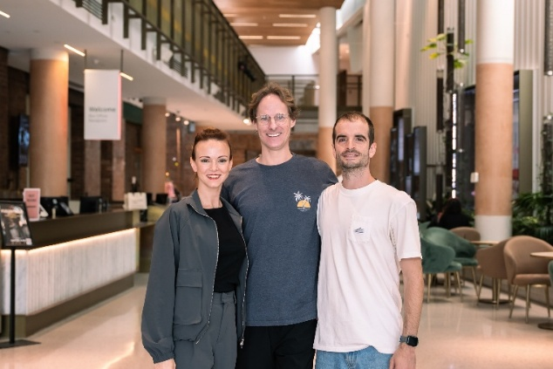
Bespoke 2026

Claire Voss, Paul Knobloch, Victor Zarallo
Brisbane, 2nd October, 2026: Today, Queensland Ballet opens its annual Bespoke season at the Talbot Theatre, Thomas Dixon Centre, presenting three new contemporary works by internationally experienced choreographers Where the Water Once Was by Claire Voss, Between the Lines by Paul Knobloch and What Remains by Victor Zarallo..
In 2026, Bespoke takes a new direction under Queensland Ballet Artistic Director Ivan Gil-Ortega, who invited artists from across the dance world to submit original concepts that push the boundaries of movement, music and design. From those submissions, three standout ideas were selected and developed into new works.
“Part of my vision is to give all choreographers and designers the opportunity to create and collaborate. When artists from different disciplines come together, it sparks new ideas and allows bold new voices to emerge.”
“I trained in the tradition of the legendary choreographer John Cranko and was aware of how he nurtured and influenced a generation of choreographic voices such as Sir Kenneth MacMillian, Sir Peter Wright and German choreographer, Christian Spuck, whose works we presented this year.”
“Choreographers Claire Voss, Victor Zarallo, and Paul Knobloch each bring a distinctive creative spark to their concepts. By giving them the space and support to bring their visions to life, we’re helping shape the future of the artform,” Gil-Ortega added.
While each work inhabits a very different world, they are connected by a common question: how do we respond to the forces that challenge our sense of identity, security and balance?
Claire Voss turns her attention to one of the most pressing challenges facing the planet in Where the Water Once Was. Created with composer Connor D’Netto, the work confronts climate change, water scarcity and humanity’s increasingly complex relationship with one of our most fundamental resources. Featuring 12 dancers, with women representing water and men embodying drought-stricken landscapes, the work asks audiences to consider the consequences of our everyday choices and our shared responsibility for the future.
Paul Knobloch’s Between the Line, created with composer Matej Perunicic, turns the examination inward. Exploring the delicate space between angst and ease, the work considers how pressure, perfection and the desire for control manifest in the mind and body. As repetition and rhythm intensify, movement becomes a pathway
1/2
towards release, inviting us to surrender what cannot be controlled and find moments of balance amid uncertainty.
Vitor Zarallo’s What Remains created with composer Brady Watkins, explores the tension between individuality and conformity. Using 20 dancers across five movements, a central female character navigates guidance, social pressure, trust and adaptation, striving to find her place within the collective without sacrificing the essence of who she is.
# ENDS #
Dates: 2 – 17 October 2026, Venue: Talbot Theatre, Thomas Dixon Centre.Tickets: $45 - $89. Available here
Editors’ Note: Interviews and photos: Claire Vince, Cvince@queenslandballet.com.au / 0468 726 910.
Photos and biographies here

About Queensland Ballet Queensland Ballet's mission is to contribute to Australia's cultural landscape by being an integral part of the national and international ballet ecology - striving for artistic excellence, pathways for emerging artists, and impact through our community outreach, education, and Dance Health programs. We aim to enrich lives and contribute to wellness across society through the magic of ballet.

FAST FACTS

- Spaniard, Victor Zarallo, first met Artistic Director, Ivan Gil-Ortega at the John Cranko School in Stuttgart where they both trained. Zarallo has worked with renowned choreographers such as David Dawson, Jiří Kylián, Hans van Manen, William Forsythe, Sir Frederick Ashton, George Balanchine, Christopher Bruce, Angelin Preljocaj, and Annabelle Lopez Ochoa.

- Throughout her career, Claire Voss performed many principle and soloist roles including the Sugar Plum Fairy in The Nutcracker, the Sylph in La Sylphide, Gamzatti in La Bayadère, Myrtha in Giselle, and Olga in Onegin.

- Paul Knobloch began his dance career in Canberra, ACT and in 2001 was awarded the Young Australian of the year ACT. He went on to perform as a principle and soloist dancer at many distinguished companies including The Australian Ballet, English National Ballet, Alonzo King LINES Ballet USA, Béjart Ballet Lausanne, West Australian Ballet and Sydney Dance Company.

- Conner D’Netto’s first opera The Call, commissioned by Opera Queensland with libretto by Kate Miller-Heidke was a finalist for the 2023 Work of The Year: Dramatic at the APRA Art Music Awards.

- Brady Watkins’ credits include creating scores for theatre such as Tiny Beautiful Things, Dead Puppets Society, The 39 Steps, Shirley Valentine, and Macbeth.

- Luke Peacock has accompanied Thelma Plum (ABC’s The Sound, Triple J’s Live At the Wireless) and played as a multi-instrumentalist for artists including Halfway, Alice Skye, Tia Gostelow, Jem Cassar-Daley and the surf-soundtrack collective, Headland.

- Designer, Bethany Cordwell gained international attention with Beyonce wearing one of her bespoke bodysuits on her album visuals for Renaissance.

- In 2020, Michelle Potts completed an online course on Fashion and Sustainability with London College of Fashion to further her understanding of the textile industry’s huge impact on our environment.

- Matthew Allan’s work includes major productions and touring shows such as The Illusionists international tours and Opera Australia’s West Side Story.
2/2

